**Number system practice questions**

1. **Convert the number 1810 to the binary system.**
2. **Convert the number 506210 to the binary system.**
3. **Convert 15910to the octal number system.**
4. **Convert 38010 to the hexadecimal number system.**
5. **Convert the binary number 110010112 to the decimal number system.**
6. **Convert the octal number 7148to the decimal number.**
7. **Convert 111012 to the decimal number system.**
8. **Convert the hexadecimal number 2C4 to the decimal number system.**
9. **Convert 10012to octal number system.**
10. **Convert 6728 to the hexadecimal number system.**

**Converting Decimal Fraction to Binary, Octal, Hexadecimal**

A fractional number is a number less than 1. It may be .5, .00453, .564, etc. We use the multiplication operation to convert decimal fraction to any other base.  
  
**To convert a decimal fraction to—**  
**• binary**- multiply by 2  
**• octal**- multiply by 8  
**• hexadecimal** - multiply by 16

## Steps for conversion of a decimal fraction to any other base are—

1. Multiply the fractional number with the to Base, to get a resulting number.  
2. The resulting number has two parts, non-fractional part and fractional part.  
3. Record the non-fractional part of the resulting number.  
4. Repeat the above steps at least four times.  
5. Write the digits in the non-fractional part starting from upwards to downwards.

## Convert 0.2345 from Base 10 to Base 2

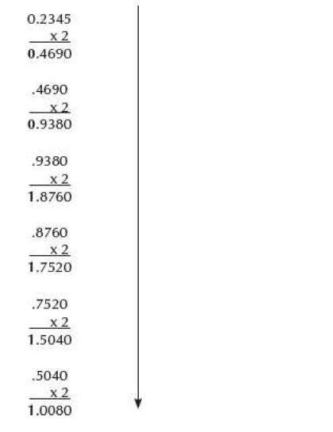

## Convert 0.865 from Base 10 to Base 2,8 and 16.

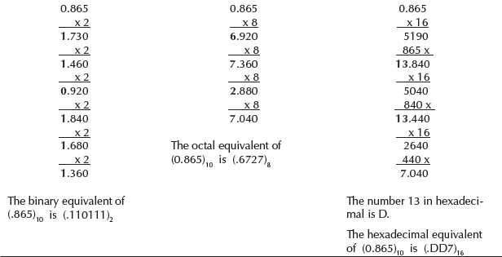

# Binary Fractions

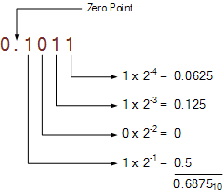

* binary number of: 1101.01112, what will be its decimal number equivalent?

Ans: 1101.01112 is given as: 13.437510

## Binary Fraction Examples

0.11 = (1×2-1) + (1×2-2) = 0.5 + 0.25 = 0.7510

11.001 = (1×21) + (1×20) + (1×2-3) = 2 + 1 + 0.125 = 3.12510

1011.111 = (1×23) + (1×21) + (1×20) (1×2-1) + (1×2-2) + (1×2-3)

= 8 + 2 + 1 + 0.5 + 0.25 + 0.125 = 11.87510

* **How to convert 101101.110 in binary to octal and hexadecimal?**

101101.110101101.110

**To octal**

First break the binary number into 3-bit chunks. For the main portion, start from the left of the binary point, and work to your left in making the chunks, and to the right of the binary point working to the right for the fractional portion. Add zeros if necessary to complete the chunking.

You should get.

101–––– 101–––– . 110

Each of those 3-bits is an octal digit. Convert to the decimal equivalent, and you'll get…

5 5 . 6

So 101101.11binary=55.6octal

To hexadecimal

It’s basically the same process, except you begin by breaking the binary number into 4-bit chunks. For the main portion, start from the left of the binary point, and work to your left in making the chunks, and to the right of the binary point working to the right for the fractional portion. Add zeros if necessary to complete the chunking.

You should get.

0010  1101 . 1100 _

Each of those 4-bits is a hexadecimal digit. Convert to the decimal equivalent, and you'll get…

2 13 . 12

For digits that have values greater than 9, their hexadecimal representation are uppercase letters A through F.

So 101101.11binary=2D.C hexadecimal

* **convert A05.9A hexadecimal to binary and octal?**